* Simple task storyboard
  + Simple Task- A checklist where students can add self-care activities, and check them off when they are completed.
  + This story board tells the story of Fred, a 20 year old college student who utilizes a checklist style journal to remind himself of a daily self-care task

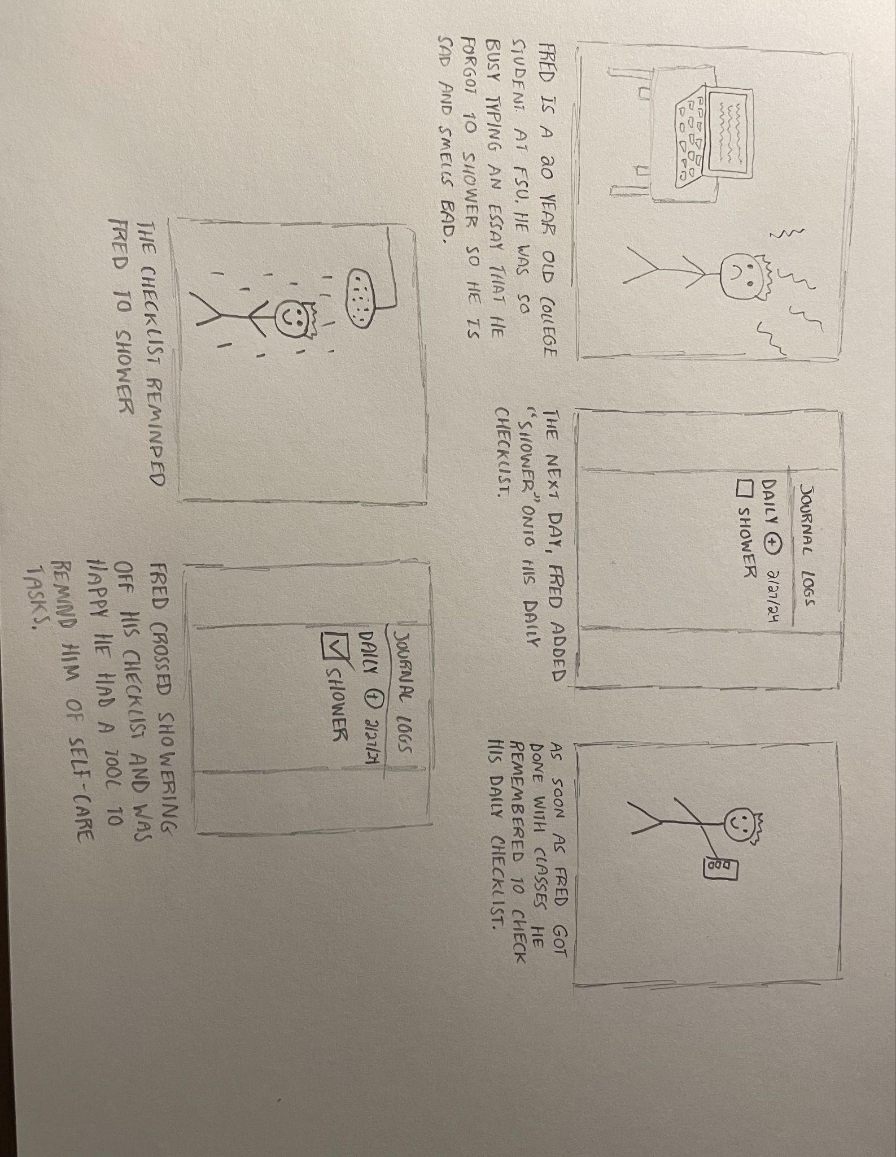

* Medium Task Storyboard
  + Medium Task- A guide for students to see recommended self-care activities and to create/check off their own self-care tasks
  + This storyboard demonstrates the use-case for our medium task from the point of view of Julie, a freshman at FSU. Julie uses self-care resources she found on her school’s wellness guide to improve her mental health. Julie found out about the FSU Rez through the resource’s page and added “Visit the Rez” to her journal checklist. The checklist helped remind Julie to complete an activity that she deemed helpful to her self-care.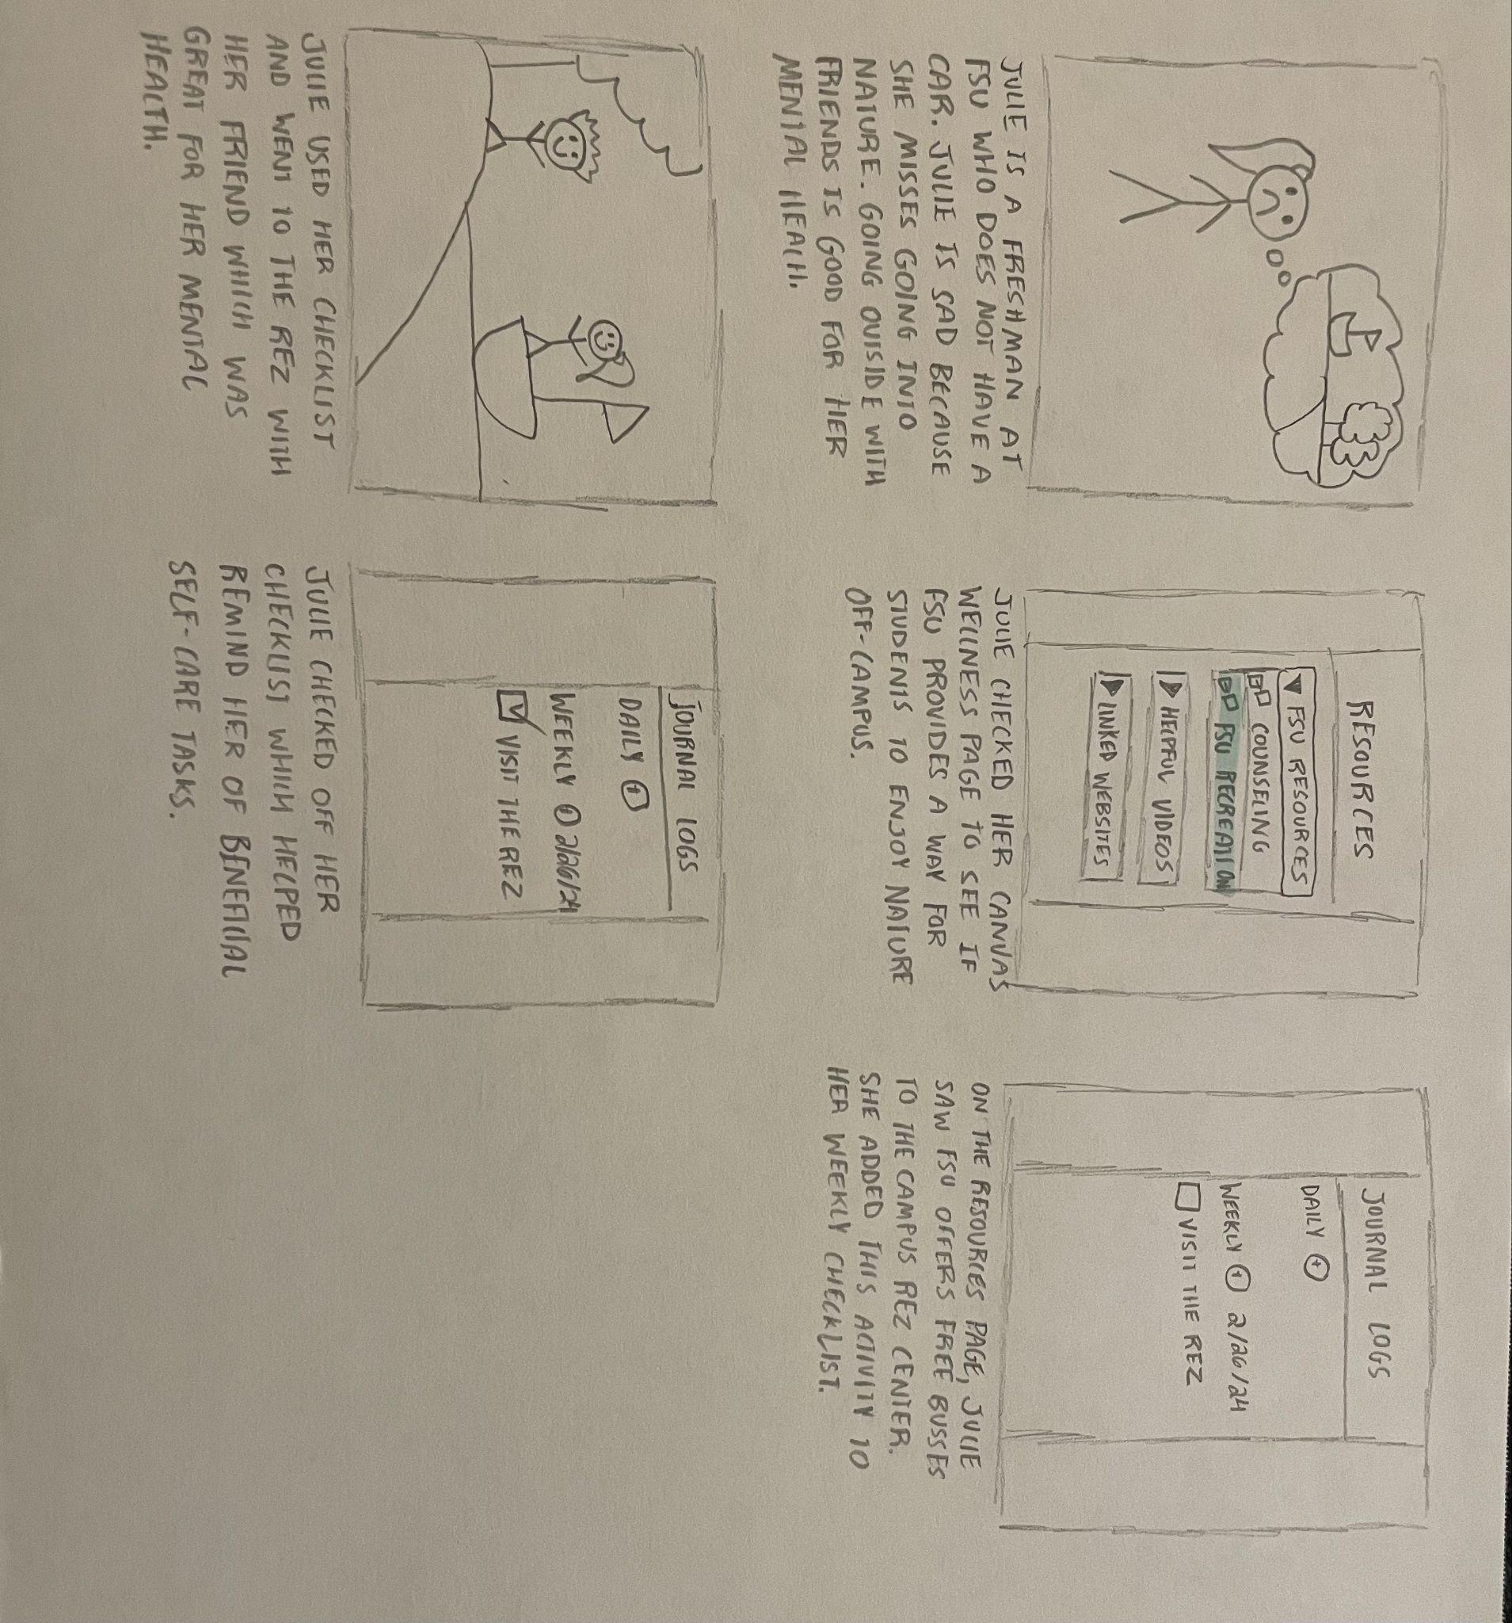
* Complex Task Storyboard
  + Complex Task- An interactive college Canvas “course” that students can use to track their self-care tasks, find direct links to self-care resources, and have access to announcements that highlight helpful on-campus events and connect with friends.
  + This storyboard demonstrates the use-case for our complex task from the point of view of Jordan, a senior at FSU who is experiencing senoritis. Jordan used his interactive wellness course attached to his Canvas course to be notified of current self-care events going around on campus that he can go to with friends, explore self-care resources, and to journal in an interactive checklist. By doing these things, Jordan helped combat some of the symptoms of his senioritis by remembering to exercise, get sunlight, and interact with new people.

